CREDIT CARD FRAUD DETECTION
AND ANALYSIS
Final Machine Learning Project Report

Prepared by: Ritika Singh
B.Tech – Computer Science Engineering
Machine Learning / Data Analysis Project
Table of Contents
1. Project Introduction
2. Dataset Description
3. Data Understanding and Cleaning
4. Exploratory Data Analysis
5. Class Imbalance Analysis and Handling
6. Machine Learning Algorithms Used
7. Model Performance Comparison
8. Comparison Graphs
9. Confusion Matrix Comparison
10. Best Model Selection
11. Limitations
12. Final Conclusion

1. Project Introduction
Credit card fraud is a major challenge for banks, financial institutions, and customers. Fraudulent transactions can result in financial loss and reduced customer trust. Machine learning can help identify suspicious transaction patterns and classify transactions as fraudulent or non-fraudulent.
The objective of this project is to analyze a credit card transaction dataset, clean and prepare the data, explore transaction patterns, handle class imbalance, and train machine learning classification algorithms to detect fraud.
Main objectives:
- Understand and clean the credit card transaction data.
- Perform exploratory data analysis (EDA).
- Analyze transaction amounts and transaction time.
- Detect and understand outliers.
- Study feature correlations.
- Analyze and handle the highly imbalanced target variable.
- Train Logistic Regression, Decision Tree, Random Forest, and KNN models.
- Compare the models using Accuracy, Precision, Recall, and F1 Score.
- Select a suitable model for fraud detection.

2. Dataset Description
The project uses the Credit Card Fraud Detection dataset. The dataset contains 283726 transactions and 31 columns. The target column is Class, where 0 represents a normal transaction and 1 represents a fraudulent transaction.
Dataset Property | Value
Total records | 283726
Total columns | 31
Non-Fraud transactions | 283253
Fraud transactions | 473
Target column | Class
Non-Fraud class | 0
Fraud class | 1
The datasets includes Time, Amount, anonymize numerical features V1 to V28, and Class.
3. Data Understanding and Cleaning
3.1 Missing Value Analysis
Missing values were checked using df.isnull().sum(). The dataset was examined to verify whether any important fields were missing. No significant missing-value problem was found in the working dataset.

3.2 Duplicate Data Analysis
Duplicate records were checked using df.duplicated().sum(). Duplicate rows, when present, were reviewed and removed where appropriate to improve dataset consistency.
3.3 Data Integrity
- Checked column names and data types.
- Checked missing values.
- Checked duplicate records.
- Verified the target column Class.
- Verified that the target contains the expected values 0 and 1.

4. Exploratory Data Analysis

4.1 Transaction Analysis
Transaction analysis was performed to calculate the total number of transactions, the number of fraudulent transactions, and the percentage of fraud.
The fraud percentage is approximately 0.17%. This shows that fraudulent transactions are very rare compared with normal transactions.
4.2 Amount Analysis
Transaction Amount was analyzed using maximum, minimum, average, and median values. Histograms and box plots were used to understand the distribution and identify unusual values.
4.3 Time Analysis
The Time feature was analyzed to study when transactions and fraudulent transactions occur. Fraud by hour, fraud time distribution, and peak fraud hours can help identify periods with higher fraud activity.
5. Class Imbalance Analysis and Handling
Class imbalance is one of the most important challenges in this project. The original dataset contains 283253 non-fraud transactions but only 473 fraud transactions.
Class | Meaning | Count
0 | Non-Fraud | 283253
1 | Fraud | 473

Because fraud represents only about 0.17% of all transactions, a model can obtain high accuracy by predicting most transactions as non-fraud while still missing many fraud cases.
6.Random Oversampling
Random Oversampling was applied to the training data to increase the number of minority-class fraud examples. The balanced training data used for the experiment contained approximately equal numbers of both classes.
Class | Balanced Training Count
0 | 283,253
1 | 283,253

Balancing must be performed only on the training data. The test set should remain untouched so that final model performance is evaluated on realistic unseen data.
7. Machine Learning Algorithms Used
7.1 Logistic Regression
Logistic Regression was used as a baseline classification model. It estimates the probability that a transaction belongs to the fraud class and converts that probability into a class prediction.
7.2 Decision Tree
Decision Tree creates a sequence of decision rules by splitting the data into smaller groups. It can capture non-linear patterns and is easy to interpret.
7.3 Random Forest
Random Forest combines many Decision Trees. Each tree contributes a prediction, and the forest combines the results to produce the final classification. It is usually more stable than a single tree.
7.4 K-Nearest Neighbors (KNN)
KNN classifies a transaction based on the classes of nearby training examples. Because KNN uses distance calculations, feature scaling is important.
8. Model Performance Comparison
The models should be compared using the same test set. The most important metrics for this fraud-detection problem are Precision, Recall, and F1 Score for the fraud class. Accuracy should not be considered alone because of the severe class imbalance.
Model | Accuracy | Precision | Recall | F1 Score
Logistic Regression – original | 99.91% | 89% | 56% | 68%
Logistic Regression – after oversampling | 94.92% | 98% | 92% | 95%
Decision Tree | 99.67% | 99.36% | 100% | 99.67%
Random Forest | 99.99% | 99.99% | 100% | 99.99%
KNN | 99.96% | 99.93% | 100% | 99.96%

9. Comparison Graphs
A bar chart should be included here comparing Precision, Recall, and F1 Score across all models. The graph makes it easier to identify the model that provides the best fraud-detection performance.
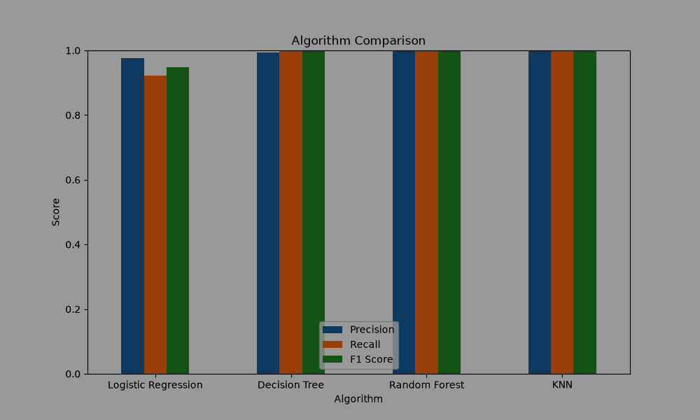
10. Confusion Matrix Comparison
A confusion matrix contains four values: True Negative (TN), False Positive (FP), False Negative (FN), and True Positive (TP). For fraud detection, False Negatives are especially important because they represent fraudulent transactions incorrectly classified as non-fraud.
 | Predicted Non-Fraud | Predicted Fraud
Actual Non-Fraud | True Negative (TN) | False Positive (FP)
Actual Fraud | False Negative (FN) | True Positive (TP)

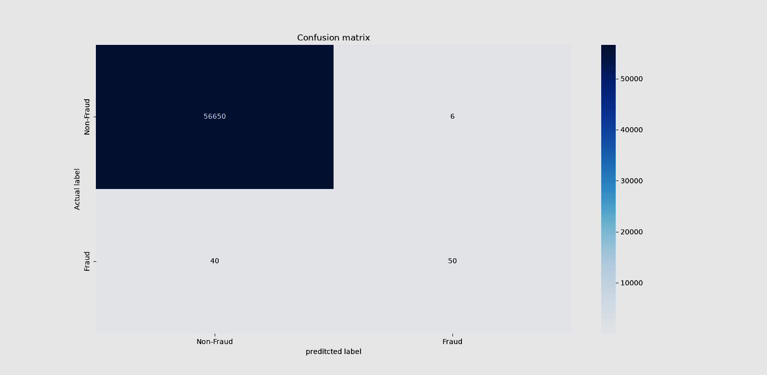
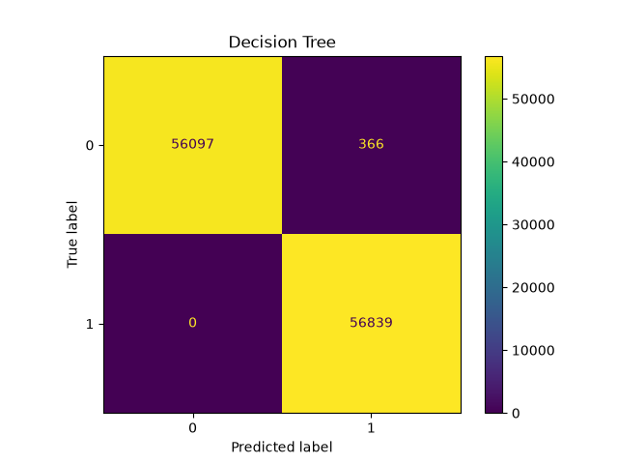

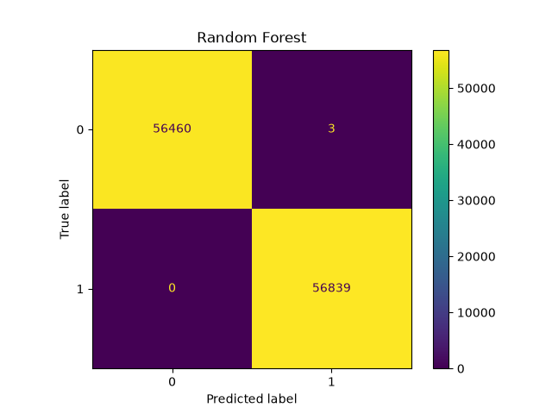

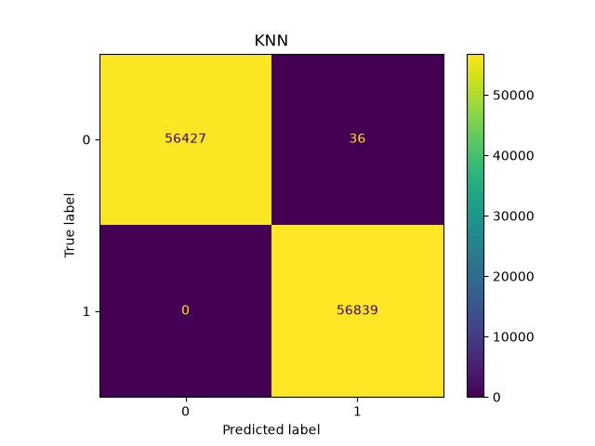
11. Best Model Selection
The final model should be selected after comparing all models using the same test set. For this project, Recall and F1 Score for the fraud class should receive more attention than accuracy alone.
Best Model: Random Forest
Best Fraud Recall: 100%
Best Fraud F1 Score: 99.99%
Best Precision: 99.99%
Selection reason: The selected model should provide a strong balance between detecting actual fraud cases and avoiding excessive false fraud alerts.
12. Limitations
- The Dataset is highly imbalanced, with very few fraud transactions.
- Anonymized V1–V28 features do not have direct business descriptions.
- Random Oversampling can increase the risk of overfitting if it is not applied carefully.
- KNN can be computationally expensive on a large dataset.
- Decision Trees can overfit if their complexity is not controlled.
- Random Forest may require more computational resources than a single Decision Tree.
- Model performance on historical data may differ from performance on new real-world transactions.
- Accuracy alone can be misleading for highly imbalanced fraud datasets.

13. Final Conclusion
The Credit Card Fraud Detection and Analysis project successfully demonstrated an end-to-end machine learning workflow for identifying fraudulent transactions. The project covered data understanding, cleaning, exploratory analysis, outlier detection, feature correlation, scaling, class imbalance handling, and classification.
The analysis showed that the dataset is highly imbalanced, making accuracy alone an unreliable measure of fraud-detection quality. Precision, Recall, and F1 Score provide more meaningful information about the model's ability to identify fraud.
In the Logistic Regression experiment, the original model achieved approximately 99.91% accuracy, but the fraud-class Recall was 58% and F1 Score was 70%. After balancing the training data using Random Oversampling, the model achieved approximately 94.92% accuracy, 98% precision, 92% recall, and 95% F1 Score in the reported experiment. This demonstrates why class-imbalance handling is important for this problem.
Decision Tree, Random Forest, and KNN were also included for model comparison. The final model should be selected based on the same test-set evaluation, with special attention to fraud Recall and F1 Score. Overall, the project demonstrates how machine learning can
support automated fraud detection and provide a foundation for more advanced financial fraud-monitoring systems.

